DBMS Practice1

SECTION 1 : DDL (DATA DEFINITION LANGUAGE)

DDL COMMANDS:
- CREATE
- ALTER
- DROP
- TRUNCATE
- RENAME

QUESTION 1 - CREATE TABLE

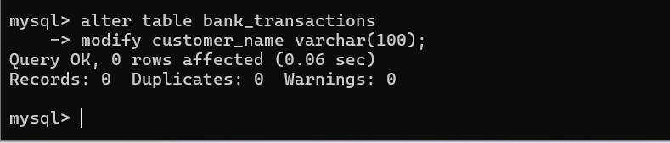
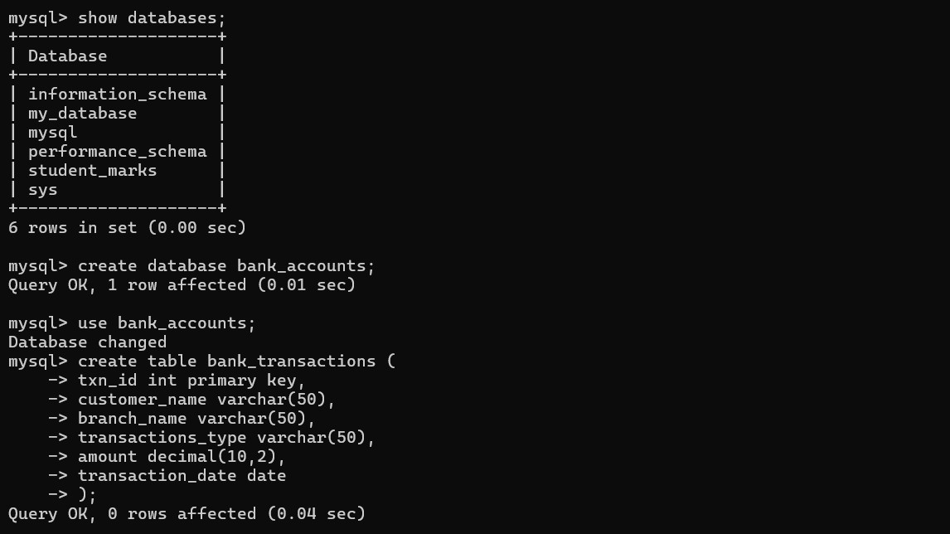

QUESTION 2 - ALTER TABLE ADD COLUMN
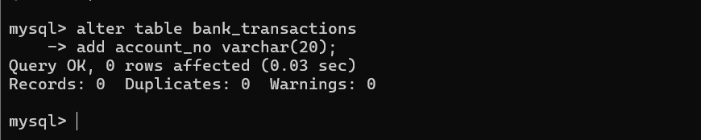

QUESTION 3 - ALTER TABLE MODIFY COLUMN QUESTION 4 - RENAME TABLE

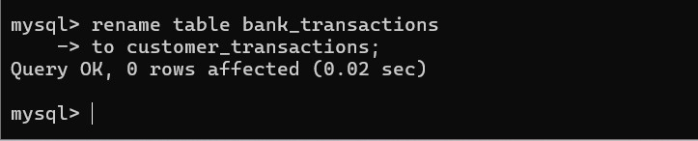

QUESTION 5 - TRUNCATE TABLE

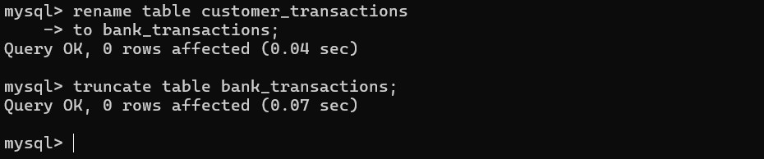

QUESTION 6 - DROP TABLE

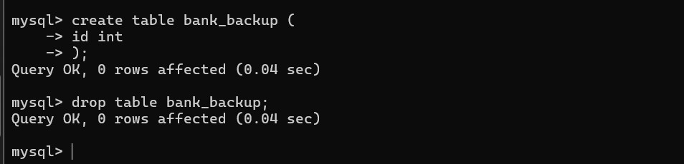

SECTION 2 : DML (DATA MANIPULATION LANGUAGE)

DML COMMANDS:
- INSERT
- UPDATE
- DELETE
- SELECT

STEP 1 : INSERT SAMPLE DATA
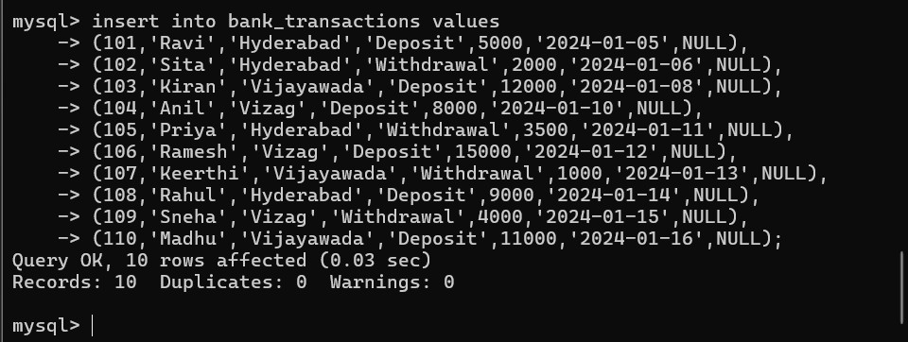

QUESTION 7 – INSERT
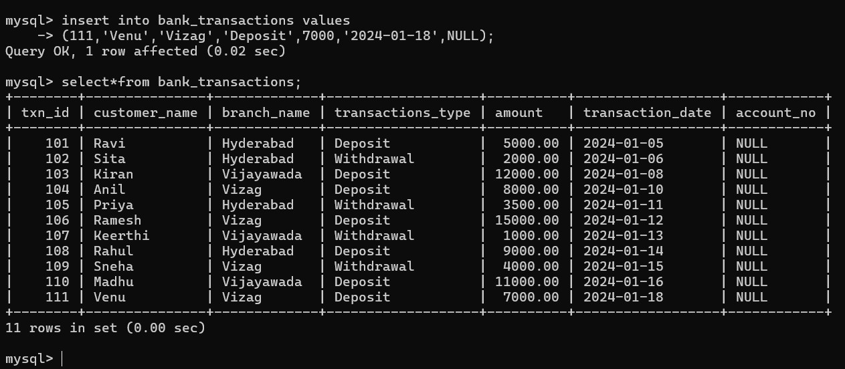

QUESTION 8 – UPDATE
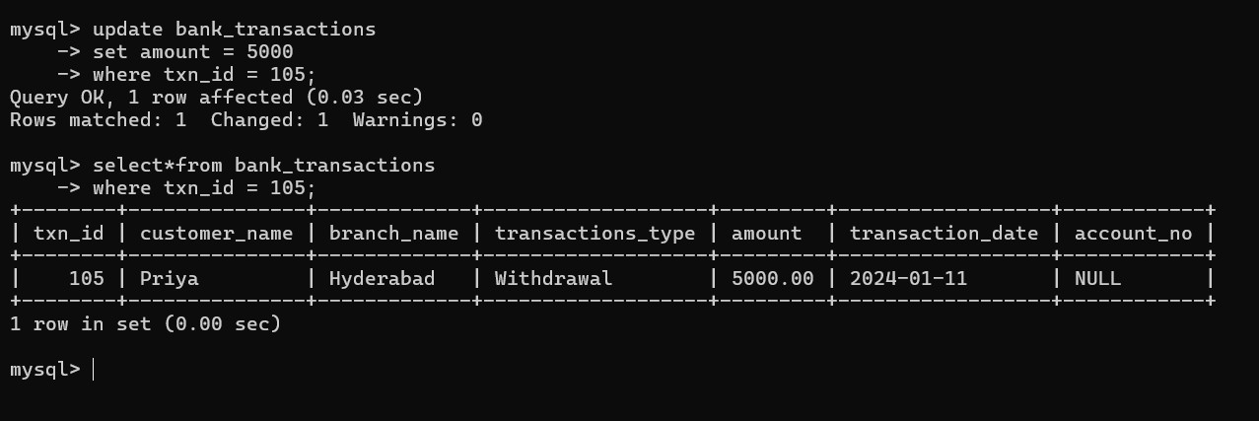

QUESTION 9 – DELETE

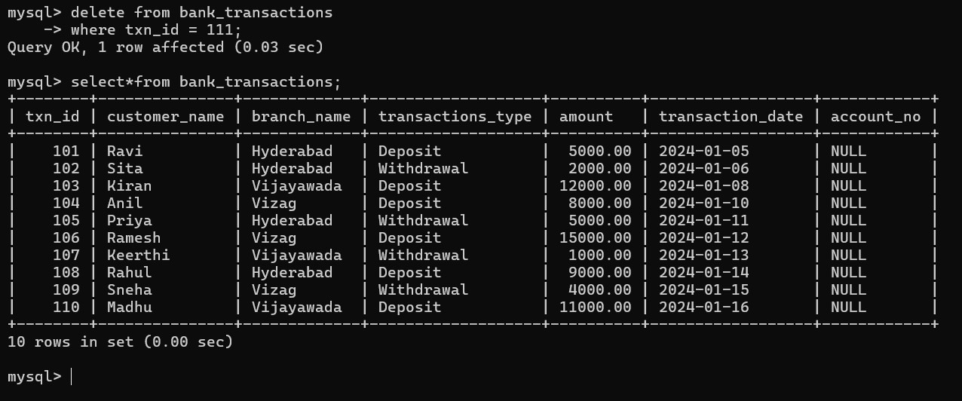

QUESTION 10 - SELECT

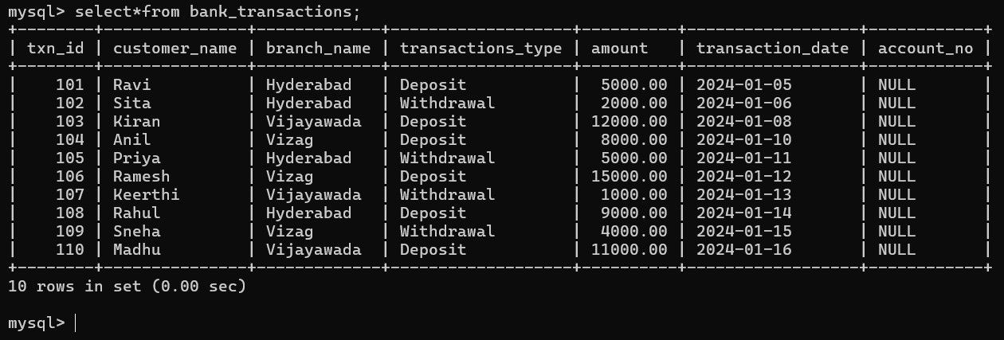

QUESTION 11 SELECT WITH WHERE
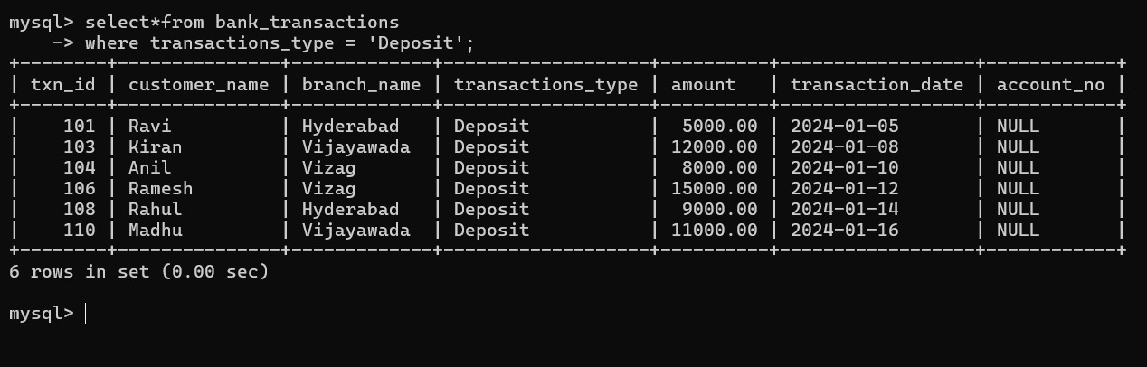

QUESTION 12 - SELECT WITH ORDER BY
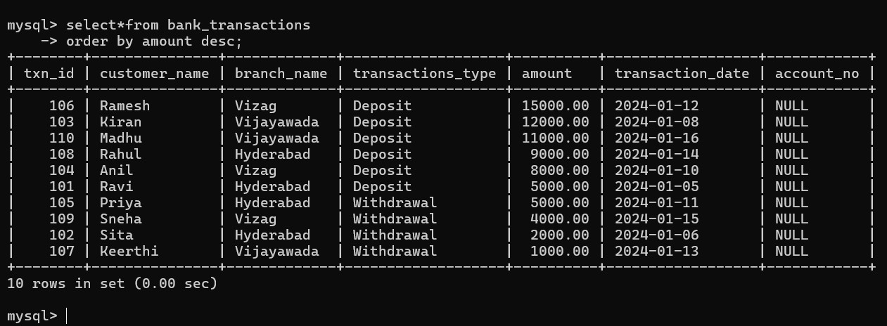

SECTION 3 : DCL (DATA CONTROL LANGUAGE)

DCL COMMANDS:
- GRANT
- REVOKE

QUESTION 13 - GRANT SELECT
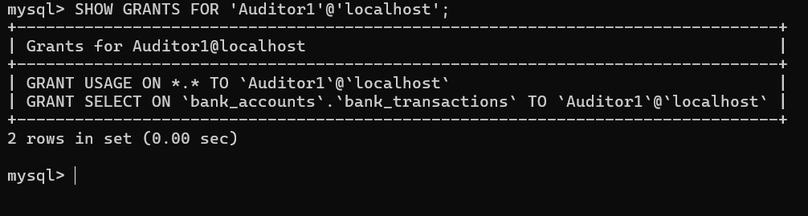

QUESTION 14 - GRANT ALL PRIVILEGES

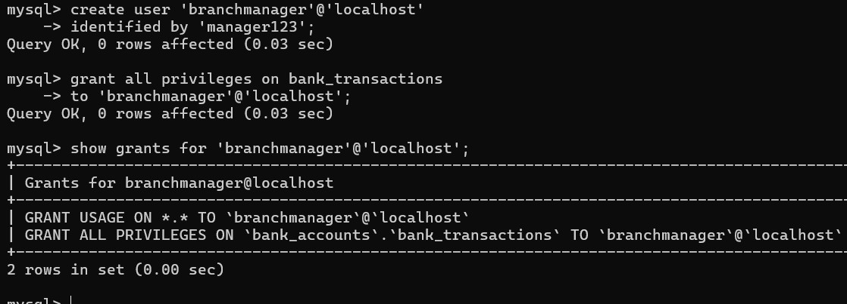

QUESTION 15 - REVOKE SELECT

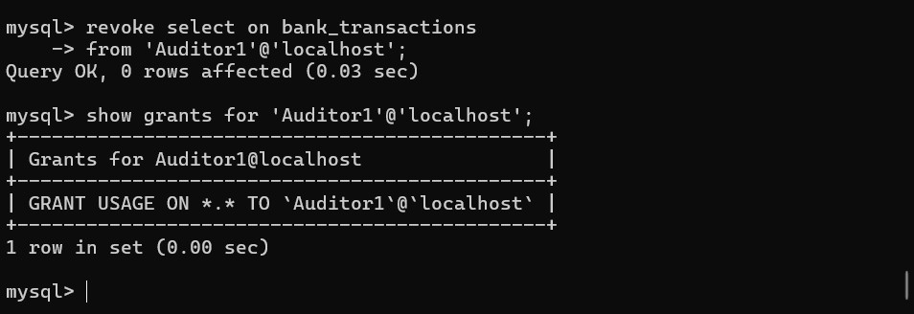

QUESTION 16 REVOKE ALL
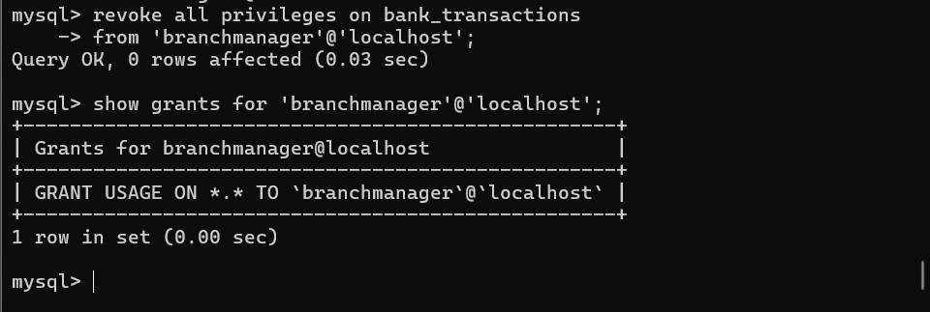

SECTION 4 : TCL (TRANSACTION CONTROL LANGUAGE)

TCL COMMANDS:
- COMMIT
- SAVEPOINT
- ROLLBACK

QUESTION 17 – COMMIT
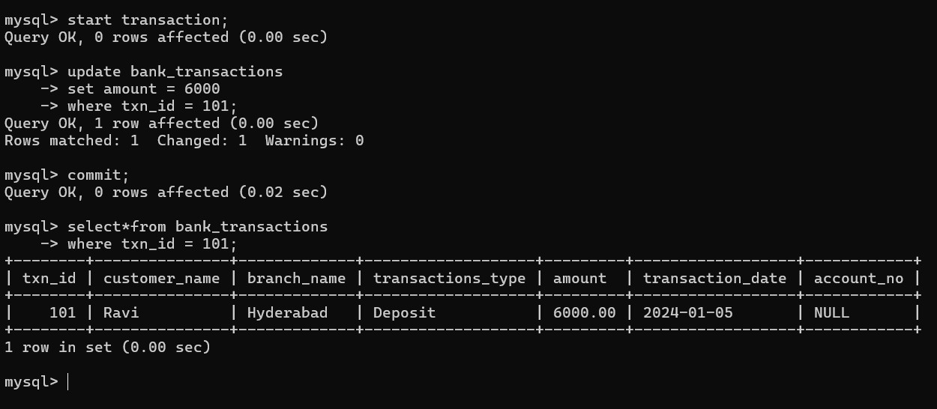

QUESTION 18 – SAVEPOINT
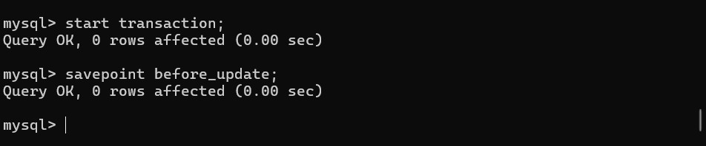

QUESTION 19 - ROLLBACK TO SAVEPOINT
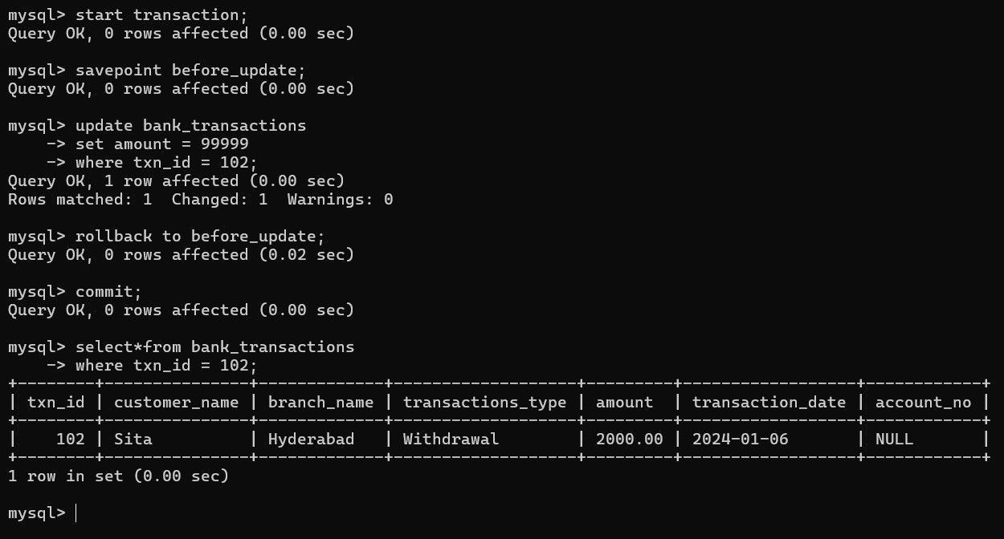

QUESTION 20 FULL TCL EXAMPLE

